Faculty of Engineering, Architecture and Science
Department of Mechanical, Industrial, and Mechatronics Engineering
Program | Electrical Engineering
Course Number | MEC511
Course Title | Thermodynamics and Fluids
Semester/Year | W2026
Instructor | Dr. Jun Cao

Lab/Tutorial Report NO. | Lab Report #4

Report Title | Lab Report #4: Steam Quality Measurement

Section No. | 09
Submission Date | March 23, 2026
Due Date | March 23, 2026

Name | Student ID | Signature*
Shai Mourad | 501170415
Chaz Dyer | 501304851
Amolika Brahmbhatt | 501295080
Glenn Bangtuan | 501327493

*By signing above you attest that you have contributed to this submission and confirm that all
work you have contributed to this submission is your own work. Any suspicion of copying or
plagiarism in this work will result in an investigation of Academic Misconduct and may result
in a “0” on the work, an “F” in the course, or possibly more severe penalties, as well as a
Disciplinary Notice on your academic record under the Student Code of Academic Conduct,
which can be found online at:
https://www.torontomu.ca/senate/policies/pol60.pdf.

Table of Contents

ii. Summary 2
1. Introduction 3
2. Apparatus 3
3. Procedure 4
4. Results & Calculations 5
4.1 Steam and Calorimeter Measurements 5
4.2 Mass of Separated Water 5
4.3 Condensate Mass 6
4.4 Table Values and Calculating x2 (Steam Quality After Throttling) 6
4.5 Calculating x1 (Steam Quality at Separator Inlet) 7
5. Discussion 8
6. Conclusion 11
7. References 12
8. Appendix 13

ii. Summary
The objective of this laboratory was to measure the steam quality (x), which is the mass fraction of saturated steam in a steam sample. Often in industrial applications, liquid droplets can erode turbine blades or minimize how efficiently the heat transfer occurs. The process to measure the steam quality involves 3 steps: firstly, large water droplets are mechanically separated and collected, then leftover steam (dried) is throttled at a constant enthalpy to ensure it is in a superheated condition. After the measurements of pressure and temperature were recorded at a steady state, the enthalpy (h₃) could be determined by referencing steam tables. The results allowed for the calculation of the entering steam quality (x₁) using the mass of the condensate and mechanically separated liquid. The steam quality after throttling was calculated to be $x_{2}=0.9786$, while the inlet steam quality values were determined as $x_{1}=0.9540, 0.9302, and 0.9163$ for Trials 1,2, and 3 respectively, with an average value of $x_{1, avg}=0.9335$. Any fluctuations in the data could be attributed to heat loss from the environment or imprecise measurements from before the system reached a steady state.

1. Introduction
The purpose of this experiment is to determine the quality of steam using calorimetric methods and to compare the results with values from standard steam tables. Steam quality refers to the fraction of vapor in a saturated liquid-vapor mixture and is an important property in thermodynamic systems, especially in applications involving heat transfer and energy conversion. In this lab, a separating calorimeter and a throttling calorimeter are used together to analyze the steam. The separating calorimeter removes any liquid droplets from the steam so that the mass of the separated water can be measured. The remaining steam then passes through the throttling calorimeter, where it expands to a lower pressure. Because throttling occurs at approximately constant enthalpy, the state of the steam after throttling can be determined using measured pressure and temperature values along with steam tables. By combining the mass measurements from the separator with the thermodynamic properties obtained after throttling, the initial steam quality at the inlet can be calculated. The experimental results are then compared with theoretical values from steam tables to assess accuracy and understand possible sources of error.

2. Apparatus
- Separating and Throttling Calorimeter
- Steam Supply Line / Boiler System
- Pressure Gauge / Manometer
- Thermometer
- Buckets (for water collection)
- Stopwatch / Timer

3. Procedure
- Turn on the cooling water to the condenser.
- Open the steam stop valve, and slowly open the blowdown valve to blow condensed water down the drain. Continue blowing down until only steam emerges from the blowdown line, then close the blowdown valve.
- Open the separator steam inlet valve and allow the system to operate until steady state is reached (condensate cooling water inlet and outlet temperatures steady).
- Turn the three way valve at the separator to the drain position to empty the separator of accumulated water, then shut the valve to begin accumulating liquid and start the clock.
- Start collecting condensate from the condenser drain line and continue collecting for the time period specified by the instructor.
- Record all temperatures and pressures.
- At the end of the collection period, close the separator steam inlet valve and stop collecting condensate.
- To collect the mechanically separated water, crack the condenser steam inlet valve to slightly pressurize the system, and open the three way valve at the separator to direct the separated water to a beaker already containing a known mass of cold water to reduce burn hazard.
- Obtain at least three sets of readings.
- Close the steam supply valve, wait five minutes, then close the condenser cooling water valves.

4. Results & Calculations

4.1 Steam and Calorimeter Measurements
Table 1. Summary of Recorded Steam Conditions
Parameter | Units | Trial 1 | Trial 2 | Trial 3 | Average
Time | minutes | 10 | 20 | 30 | 10
Steam Inlet Pressure | psig | 56.5 | 56.0 | “ ” | 56.25
Steam Inlet Temperature | °F | 295 | 292 | “ ” | 293.5
Steam Temp. in Throttling Calorimeter | °F | 240 | 242 | “ ” | 241
Steam Pressure in Calorimeter | mmHg | 87.5 | 89 | “ ” | 87
Cooling Water Inlet Temperature | °F | 46 | 46 | “ ” | 46
Cooling Water Outlet Temperature | °F | 71 | 71 | “ ” | 71
Condensate Temperature | °F | 78.5 | 79 | “ ” | 78.75

4.2 Mass of Separated Water
Table 2. Separated Water Mass Measurements
Measurement | Trial 1 | Trial 2 | Trial 3
Weight of beaker + cold water (kg) | 1.530 | “ ” | “ ”
Weight of beaker + cold water + separated water (kg) | 1.575 | 1.625 | 1.655
Mass of separated water (kg) - (m_{sep}) | 0.045 | 0.095 | 0.125

4.3 Condensate Mass
Table 3. Condensate Mass Measurements
Measurement | Trial 1 | Trial 2 | Trial 3
Weight of collecting vessel (kg) | 2.255 | — | —
Weight of vessel + condensate (kg) | 4.005 | 4.080 | 4.095
Mass of condensate (kg) (m_{cond}) | 1.750 | 1.825 | 1.840

4.4 Table Values and Calculating x₂ (Steam Quality After Throttling)
The steam inlet pressure is given as 56 psig. Converting to absolute pressure:
$P_{abs}​=P_{gauge}+P_{atm}=56+14.7=70.7 psia ≈ 487 kPa$
Using the saturated water pressure tables (see Appendix for Table A-9), the corresponding properties at 487 kPa are:
$h_{f }= 640 kJ/kg$ [1]
$h_{g }= 2745 kJ/kg$ [1]
These values were obtained using linear interpolation between the closest pressure values in the saturated water tables.
Throttling calorimeter measurements give:
$T_{2}≈240-242°F≈115-117°C$
$p_{2}≈87-89 mmHg≈11-12 kPa$
The saturation temperature is significantly lower than the measured temperature, indicating that the steam is in the superheated region.
$h_{2}​ ≈ 2700kJ/kg$ [1]
Therefore, the steam quality after throttling, $x_{2}$ is
$x_{2} = \frac{h_{2} - h_{f}}{h_{g} - h_{f}} = \frac{2700 - 640}{2745 - 640} = 0.9786$ Eq. 1

4.5 Calculating x₁ (Steam Quality at Separator Inlet)
Using the equation found in the lab manual, the steam quality at the separator inlet for the 3 trials are:
$x_{1} = \frac{x_{2}m_{cond}}{m_{cond} + m_{sep}}$ Eq. 2

Trial 1:

$x_{1} = \frac{(0.9786)(1.750)}{1.750 + 0.045} = 0.9540$

Trial 2:

$x_{1} = \frac{(0.9786)(1.825)}{1.825 + 0.095} = 0.9302$

Trial 3:

$x_{1} = \frac{(0.9786)(1.840)}{1.840 + 0.125} = 0.9163$
Table 4. Summary of Steam Quality Calculations (x₁ and x₂)
Trial | x₂ | x₁
1 | 0.9786 | 0.9540
2 | 0.9786 | 0.9302
3 | 0.9786 | 0.9163
Average | 0.9786 | 0.9335

5. Discussion
The objective of this experiment was to determine the steam quality at two locations in the system: after mechanical separation ($x_{2}$) and at the separator inlet ($x_{1}$). From the results obtained, the steam quality after throttling was calculated to be $x_{2}=0.9786$, indicating that the steam was nearly dry saturated vapor with a very small liquid fraction after passing through the separating calorimeter. The inlet steam quality values were determined as $x_{1}=0.9540, 0.9302, and 0.9163$ for Trials 1,2, and 3 respectively, with an average value of $x_{1, avg}=0.9335$. These results show that the incoming steam contained a small but significant fraction of liquid water, which was successfully removed by the separating calorimeter.
Equation (3) in the lab manual, used to calculate the inlet steam quality, is given by $x_{1} = \frac{x_{2}m_{cond}}{m_{cond} + m_{sep}}$. This equation is verified through a mass balance on the system. The total mass of steam entering the calorimeter is equal to the sum of the mass of condensate collected in the condenser ($m_{cond}$) and the mass of liquid water mechanically separated ($m_{sep}$). Since the throttled steam is assumed to be fully condensed, the condensate represents the vapor portion of the incoming mixture. Therefore, multiplying the vapor fraction after throttling ($x_{2}$) by the condensate mass accounts for the vapor content of the original steam, validating the equation.
The thermodynamic process can be visualized on the Mollier (enthalpy–entropy or h–s) diagram shown in Figure A-8. Initially, the steam at state 1 lies within the saturated mixture region under the dome, corresponding to a quality $x_{1}<1$. After passing through the separating calorimeter, large liquid droplets are removed, shifting the state closer to the saturated vapor line (state 2). The remaining steam then undergoes a throttling process to a much lower pressure. Since throttling is an isenthalpic (constant) process ($h_{2}=h_{3}$), the state moves horizontally to the right at constant enthalpy on the Mollier diagram into the superheated region (state 3). This confirms that the measured temperature after throttling is higher than the saturation temperature at the reduced pressure, validating the assumption used in determining $h_{2}$.
Several sources of error may have affected the accuracy of the results. Heat losses to the surroundings could have caused deviations in the measured temperatures, leading to incorrect enthalpy values. Inaccurate readings from pressure gauges and thermometers, particularly at low pressures in the throttling calorimeter, may have introduced uncertainty in determining the thermodynamic state. Additionally, incomplete separation of liquid droplets in the separating calorimeter would result in an overestimation of the steam quality. Measurement errors in determining the mass of condensate and separated water, such as scale precision or evaporation losses, could also contribute to discrepancies.
Another important factor is whether steady-state conditions were fully achieved before measurements were taken. If the system components, such as piping and valves, were still cold, additional condensation could occur within the system. This would increase the measured condensate mass and decrease the calculated steam quality, resulting in values lower than the true steam quality. Therefore, ensuring steady-state operation is critical for obtaining accurate results.
Overall, the calculated steam quality values are consistent with expected behavior for wet steam in industrial systems. The decreasing trend in $x_{1}$​ across trials may indicate experimental variability or slight inconsistencies in operating conditions. Despite these limitations, the experiment successfully demonstrated the use of separating and throttling calorimeters to determine steam quality and reinforced the thermodynamic principles of phase change and isenthalpic processes.
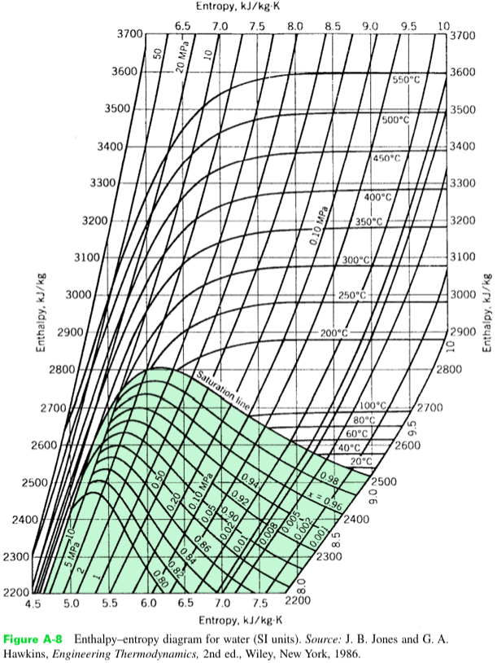

State 1
State 2
State 3
In this sketch, there are 3 states:
- State 1 (Wet Steam)
  - $Pressure≈0.487 MPa$
  - $Quality≈0.93$
  - Plot inside the dome (liquid and vapor region) below 0.50 pressure line (MPa) and between 0.92 and 0.94 quality line (x)

- State 2 (After Separation)
  - $Same Pressure≈0.487 MPa$
  - $Higher Quality≈0.98$
  - Plot inside the dome (liquid and vapor region) below 0.50 pressure line (MPa) and on the 0.98 quality line (x)
- State 3 (After Throttling)
  - $Pressure≈12 kPa≈0.012 MPa$
  - $Temperature≈117°C$
  - Plot outside and to the right of the dome (superheated vapor region) on the 0.01 pressure line (MPa) and above the 100$°C$ temperature line (sketch horizontal line from state 2 to state 3 since enthalpy is constant)

6. Conclusion
The goal of this experiment was to determine the steam quality using a combination of a separating calorimeter and a throttling calorimeter. By measuring the mass of condensate and mechanically separated water, along with pressure and temperature data, the steam quality at both the separator outlet and inlet was successfully determined.
The steam quality after throttling was calculated to be $x_{2}=0.9786$, which means that the steam was nearly dry saturated vapor after passing through the separating calorimeter. The inlet steam quality values were calculated as $x_{1}=0.9540, 0.9302, and 0.9163$ for Trials 1,2, and 3 respectively. These results confirm that the incoming steam contained a small fraction of liquid water, which was effectively removed by the separating calorimeter.
The results obtained are reasonable and consistent with expected thermodynamic behavior of wet steam. Minor discrepancies between trials can be attributed to experimental errors such as heat losses, measurement uncertainties, and possible deviations from steady-state conditions.
In conclusion, the experiment successfully demonstrated the application of calorimetric methods and steam tables in determining steam quality and reinforced the principles of phase change and isenthalpic (constant) processes in thermodynamics.

7. References

[1] S. Thomas, Thermodynamic Properties of Water and Steam Tables, Wright State University. Available: https://cecs.wright.edu/people/faculty/sthomas/htappendix01.pdf
[2] R. S. Budny, MEC511 Laboratory Manual: Steam Quality Measurement (Lab 4), Dept. of Mechanical and Industrial Engineering, Faculty of Engineering, Architecture and Science, Ryerson University, Jan. 2016.

8. Appendix
Table A-9. Properties of Saturated Water [1]
